ELEC2230 – Tutorial No. 2

Calculate the insertion loss, in decibels, for the following circuits. Assume a 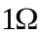 source and load impedance.
1F
F-1Hz
1) 2)
L=2H
F=1Hz

3) 4)
L=1NH

C =1nF
F =1GHz
f =1MHz

_________________________
_________________________

Derive expressions for, and plot the insertion loss of the following circuits as a function of angular frequency.

5)
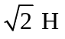

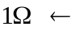

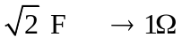

6)
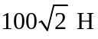

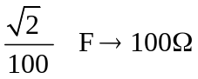

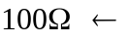

____________________
____________________

7) Given, for a lossless circuit

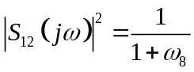

Find 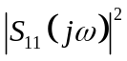 and the return loss.

8) Find the return loss of the following circuit in a 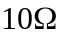 system.

10H
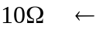

9) Design a quarter-wave transformer to match a 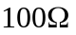 source to a 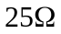 load at a frequency of 1GHz.

10) Derive an expression for, and plot the Insertion loss as a function of angular frequency for the following circuit.

